# Beam Profile Apparatus

## Apparatus

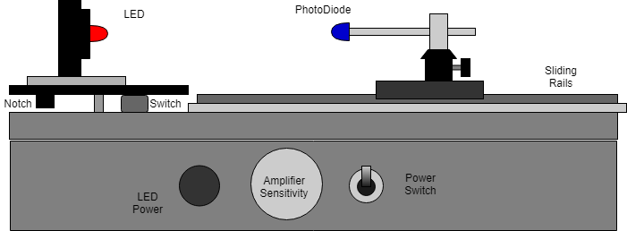

Figure Front View

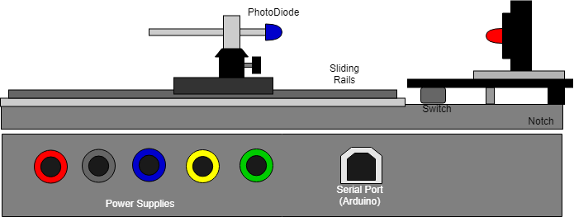

Figure Back View

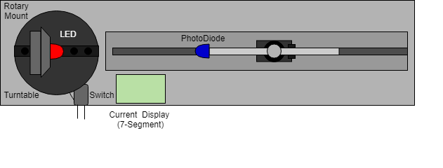

Figure Top View

## Electronics

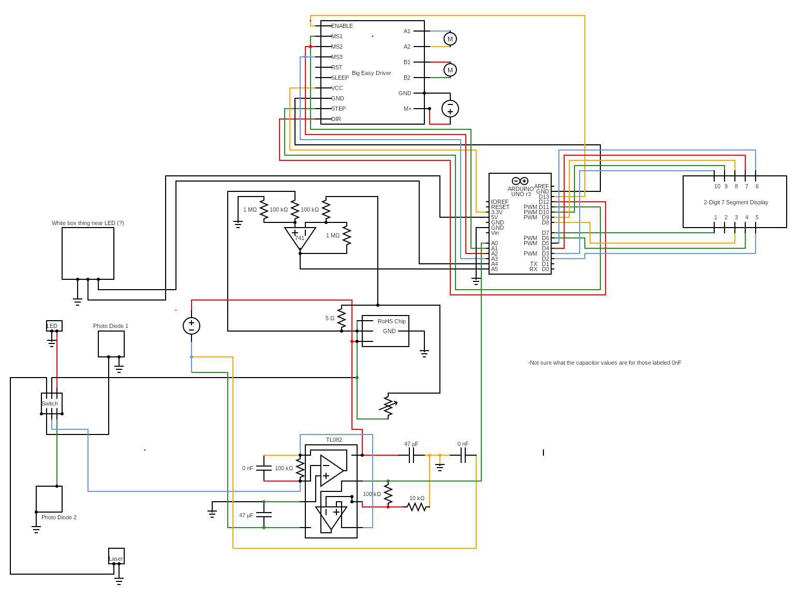

Figure 4 Circuit Schematic

## Procedure

### Beam Profile

1. Download/Clone UV-Sintec github (<https://github.com/Barry8197/UV-Sintec>)
2. Upload BeamProfiler.ino to Arduino
3. Plug in Power Sources (separate supply for the motor and circuitry). 13V positive and negative and 13V to motor separately. The red, blue, and black input ports are for powering the amplifiers, Arduino and LED power. The yellow and green (ground) are for powering the motor. These supplies can be connected together but will receive more noise on the line when powered together
4. Centre LED over the centre of the Turntable. Make sure that mounts are securely fastened to turntable to minimize the vibration felt by the LED.
5. Line up Photodiode to the centre of the LED.
6. Make sure switch is powered so that LED emits light.
7. Adjust alan key to make the switch trigger at roughly when the turntable is perpendicular to the sliding rail.
8. Run UV-Sintec/BeamProfile/LEDSweep.py. Make Sure the COM port matches that of the computer being used.
9. Cover the apparatus using the black box in order to minimize the effect of outside light.
10. The Turntable should reset itself to the home position. The Program will ask for the Product Key of the LED, the number of turns desired and the Boxcar.
11. Record the angle of the LED as per the section below
12. The Apparatus will repeat 4 times each time pausing to rotate the angle of the LED, in order to create a 3D model of the cosine response of the photodiode.
13. The program will then ask if you would like to add this to the database. ( The program will check if this is a duplicate and if you would like to overwrite the data)

### Cosine Response

1. Download/Clone UV-Sintec github (<https://github.com/Barry8197/UV-Sintec>)
2. Upload BeamProfiler.ino to Arduino
3. Plug in Power Sources (separate supply for the motor and circuitry). 13V positive and negative and 13V to motor separately. The red, blue, and black input ports are for powering the amplifiers, Arduino and LED power. The yellow and green (ground) are for powering the motor. These supplies can be connected together but will receive more noise on the line when powered together
4. Centre LED over the centre of the Turntable. Make sure as mounts are securely fastened to turntable to minimize the vibration felt by the Photodiode.
5. Line up Photodiode to the centre of the LED.
6. Make sure switch is powered so that LED emits light.
7. Adjust Alan key to make the switch trigger at roughly when the turntable is perpendicular to the sliding rail.
8. Run UV-Sintec/Cosine Response/CosineResposne.py. Make Sure the COM port matches that of the computer being used.
9. Cover the apparatus using the black box in order to minimize the effect of outside light.
10. The Turntable should reset itself to the home position. The Program will ask for the Product Key of the LED, the number of turns desired and the Boxcar.
11. Record the angle of the photodiode as per the section below
12. The Apparatus will repeat 4 times with different angles in order to create a 3D model of the cosine response of the photodiode
13. The program will then ask if you would like to add this to the database. ( The program will check if this is a duplicate and if you would like to overwrite the data)

### Angle of LED's

The angle of LED's should be documented based on the position of the anode and cathode of the LED. This can be seen in the Diagram below. The easiest way to achieve this is to use the rotary dial. Position the LED in the dial and turn until the LED legs are parallel to the turntable. Read the angle off the dial at this position. Then as you rotate the dial subtract this angle to get the true angle of the LED.

package Bottom 
View 
Side 
View 

### Example Graph of Response

LED used = 635nm

Product Key = 1125-1230-ND

Photodiode = 1080-1143-ND (5mm)

Nomalised 3D Beam Profile of an LED 
1.0 
0.8 0 
0.8 
0.0 
75 50 25 
Angle in the x-direction 
0.6 
00 
235075 
755025 0- _direction 
Angie the 

The Graph can be rotated and viewed at different angles after the program has run. Having four different angles of the LED is valuable as it allow us to create different models as the LED is rotated. The Program then adds these models into the database and the coefficients also.